Must-Have Wedding Photos Every Couple Should Get
The wedding day is a tempest of fleeting moments, emotions, and unique stories all yearning to be captured in a timelessly personal manner. If you get married in Charlotte, you quickly learn which pictures are an absolute must, pictures that don't simply record your day, but actually preserve the soul of it. It's the phrase for creating a treasure trove of memories that you will cherish forever.
Finding the Photographer Who Truly Understands
The right wedding photographers in Charlotte are much more than just someone with a camera. You want a creative partner who clicks with your style and vibe for Charlotte weddings, someone who doesn't pose these moments to force a specific look.
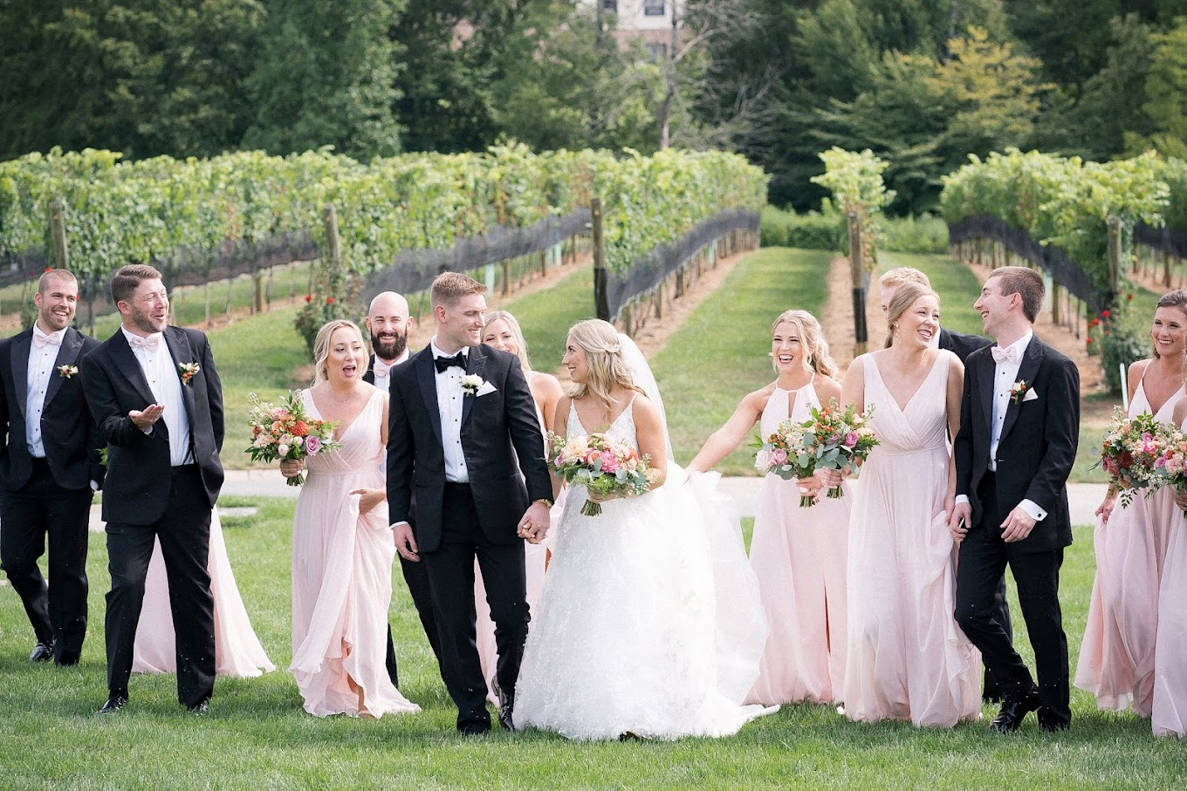
Your wedding photographer decision in Charlotte will be among people who do not merely take pictures but create stories with their camera. They edify you and record naturally occurring, genuine moments.
What are the Best Wedding Photos One Must Get?
Moments That Tell a Story
Everyone can name the typical shots, such as the exchange of vows, the kiss, and the slipping of rings upon fingers. These exist as the anchors, the heartbeats of the ceremony. But down under the album is where the rich narrative is told through the cantor of warm smiles filled with silent tears from loved ones, belly laughs during speeches, the little glances, and impromptu hugging that do not make it on the program but leave lasting impressions.
The Subtle, Poetic Beginnings and Details
The getting-ready story is potent to give rise to a wedding day. The serene climactic anticipation, sensory details, a brush with fabric, a shimmer of little jewels, soft light falling on a veil, these are the moments that a portrait photographer in Charlotte turns into art. These gorgeous preludes to the ceremony often go unnoticed and deserve to have their spotlight.
The People Who Fill Your World
Your family and friends are the background that breathes life into your celebration. Formal portraits are a little bittersweet in preserving these relationships, but candid shots with gleeful bridal attendants express the camaraderie that makes your day cherished memories.
The Intimacy and Genuine Spontaneity
Couple portraits capture moments of quiet intimacy shared between two beings alone while walking toward their new life together. Ideally, whether snapped before the ceremony buzz or after the excitement subsides, these images must feel intimate, authentic, and full of emotions. Unposed candid ones, the smiles, tears, and laughter, give life and energy to your day in
in their purest form.
Speak Up for Your Vision
An ideal wedding album rests on clear communication. Don't wait until the last moment. Get in touch with us early so that we can discuss with you your must-have shots, style preference, and any unique ideas. This ensures that your photographer will be ready to immortalize every moment exactly the way you picture it.
In a Nutshell
Wedding photography is an art of mixing-and-matching the iconic with candid shots, big moments with small, detailed ones. These layers together account for a genuine storytelling of a day.
Wedding photos and portraits with the best wedding photographers will make sure that your memories really come alive with emotion. Contact us, and let's start working on your photography adventure; your story deserves the best.

