Key Qualities to Consider When Choosing a Wedding Photographer
Photography for a wedding is among the most significant decisions of the day. Recalling such moments will be forever dear to your heart. Being there to capture such memories takes not just a camera but also intuition, artistry, and heart. Here is how to find that person who can transform your once-in-a-lifetime experience into eternal mementos.
Qualities to Look for in a Photographer for Your Big Day
1. Experience You Can Trust
There have to be years in the industry, but it cannot be about how many love stories a photographer has told. An old pro knows how to work in all the different kinds of lighting, venue, and weather conditions without missing a beat.
Couples looking for wedding photographers in Charlotte seek to find someone flexible and spontaneous, but then again, who has a calming and wholesome aura throughout the day. Such an experience is worth everything when the tensions are high and timelines start to get tight.
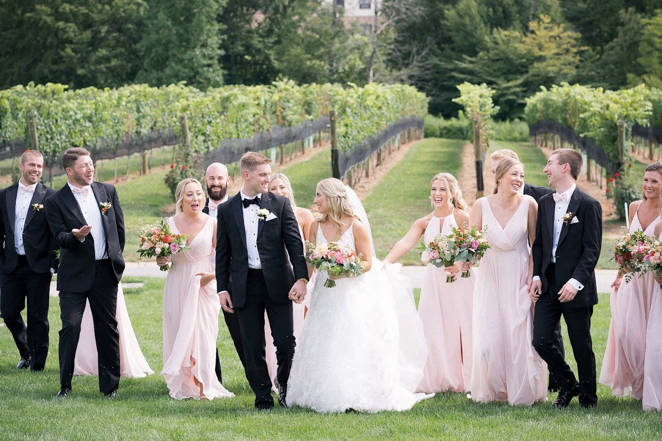
2. Style That Reflects Your Vision
Every photographer has a style of their own. Some photographers are more entitled to be moody and cinematic, while others tend to brighten the airy tones. They should spend time thoroughly browsing every wedding gallery (not just the highlight reels!) so that they would know how the photographers capture big and little moments.
These images must answer questions about their realness: Do they also have stories to tell? Can I picture myself in there? A good photographer will probably reflect their artistic style through their lens to create a package you won't stop looking at.
3. Comfort and Chemistry
The wedding photographer will be almost the last person you'll be spending time with on your wedding day. Hence, it is important to make sure that the wedding photographer you choose is comfortable working with. A good photographer knows how to coach you informally through the experience and keep it all natural and light. Whether it's during your engagement session or the very last shot at night, you must know that feeling comfortable in front of the camera has everything to do with the connection you have with the one behind it.
4. More Than Just Weddings
With weddings being the main highlight, a flexible photographer can catch every moment sprinkled along the journey of life with the same detail. True to form, the best family photographers can easily parallel what they do at their weddings. From maternity shoots to anniversary sessions, each shoot, yes, that is with warmth, vision, lustrous, and dreamy touch.
5. Take the First Step
Feel free to contact us when you are ready to talk about your big day, ask questions, or check availability. It is a simple, friendly booking process that caters to your comfort and expectations.
Instead of mere images, your wedding photos are pieces of your love story sealed in time. Selecting photographers will lead to someone who doesn't take pictures but rather photographs the story of your wedding: someone knowledgeable in lighting, timing, emotion, and your most important aspect. You.
So go ahead. Find that photographer who can capture in pixel magic the reality of your love as you see it. It might just be the beginning of a project that will take so much more than a couple to complete.

