Capturing Forever: The Rise of Wedding Photographers in Charlotte
Charlotte, North Carolina, has fast become a sought-after destination for couples tying the knot—and with its charming blend of Southern hospitality and urban elegance, it’s not hard to see why. But beyond stunning venues and picture-perfect weather lies another crucial element: wedding photographers in Charlotte who are turning moments into magic.
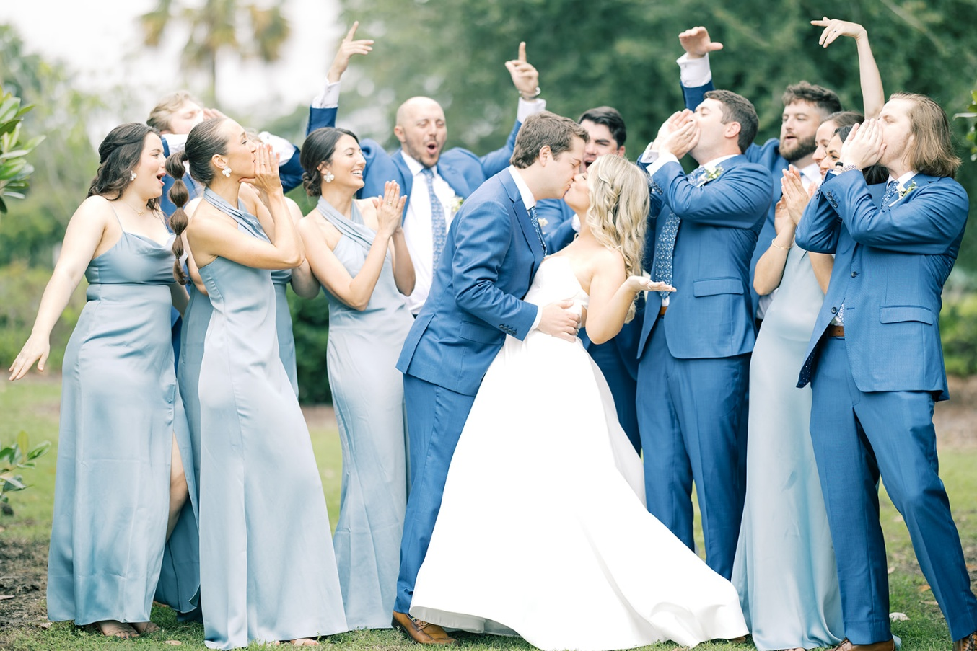
Why Charlotte Is a Photographer’s Playground
From the historic beauty of Duke Mansion to the sleek skyline views atop Fahrenheit restaurant, Charlotte offers diverse backdrops for every couple’s unique love story. The city’s wedding photographers have truly mastered the art of blending romantic ambiance with authentic emotion.
What Sets Charlotte's Wedding Photographers Apart?
- Tailored Styles: Whether you're dreaming of light-and-airy portraits, moody editorial shots, or documentary-style storytelling, photographers here often specialize in specific aesthetics.
- Local Expertise: They know how to leverage golden hour in Freedom Park or capture a couple’s candid laughter in the NoDa arts district.
- Tech-Savvy & Trend-Aware: With drones, 4K video, and instant previews, Charlotte’s professionals are combining innovation with artistry.
Choosing the Right Photographer in Charlotte
When searching for “wedding photographers” couples should consider:
- Portfolio Depth – Look for galleries that evoke emotion and tell a clear story.
- Connection – Chemistry between the photographer and the couple makes a huge difference.
- Reviews & Testimonials – Ask past clients if the experience was seamless and if the results matched expectations.
Booking Tips
- Plan Early: Peak wedding seasons (spring and fall) book up fast.
- Meet in Person: If possible, set up a consultation to ensure you vibe with your chosen photographer.
- Be Honest: Share your vision, quirks, and preferences. Transparency leads to magic.
Final Flash
Wedding photographers aren’t just service providers—they’re storytellers, artists, and sometimes even unofficial wedding-day therapists. Their photos aren’t just pretty—they’re powerful memories frozen in time. So when planning your Queen City nuptials, invest in someone who won’t just take photos, but who will truly capture your love in its purest form.
Want help crafting a vendor shortlist or some questions to ask during photographer interviews? I’ve got plenty of ideas!

